Pornography
Pornography is pictures or videos of people without their clothes on, having sex, or doing sexual things.
Pornography can also be sexy written stories and sound recordings.
When a person uses pornography it can make them feel sexy.
Pornography is sometimes called ‘porn’. Porn can be in:
- books
- magazines
- photos
- videos and films
Most people look at porn on the internet.
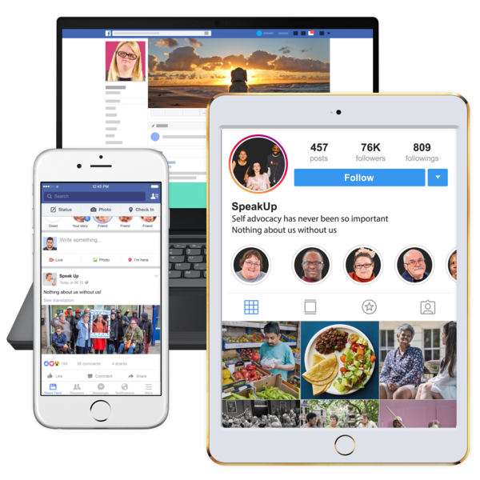
This is sometimes called looking at porn online.
Your child might use iPads, computers and phones.
These can be connected to the internet.
They might use these for:
- school
- therapy
- communication
- learning
- entertainment
Parents might feel worried about their child using things that are connected to the internet.
Parents might worry about their child seeing porn.
It is OK to be worried.
Many parents want to know how to protect their child from accidentally seeing porn.
They also want to know what to do if their child sees porn and feels upset.
What is on this page?
This page will answer some questions that parents often have about porn.
It has information on:
- how your child might find porn
- how you can stop your child from finding porn online
- what you can do if you find out your child has looked at porn online
- what you can do if your child becomes obsessed with porn
How did my child find porn?
Porn can be found in lots of different places.
Some people search for porn online or find websites that are just for porn.
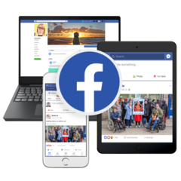
Sometimes people find porn online by accident.
They might find porn on:
- social media like Facebook, Instagram or Snapchat
- Google if they type words like “boobs”, “sex” or “naked people”
- YouTube videos or games
- links on websites or emails that are made to trick people
- games that have a chat box like Roblox or Minecraft
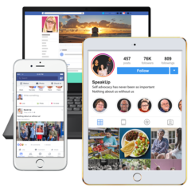
How can I stop my child from finding porn online?
Having good safety settings on iPads, phones and computers will help protect your child from porn on the internet.
You can learn more about safety settings on the Cybersafety page
If your child has a computer, phone or iPad from school or a service they go to, you will need to talk to them about the rules for using it.
If your child is over 18 years old, they are legally allowed to look at porn on the internet.
To look at porn safely they will need to:
- be in their private place.
This means their bedroom or bathroom with the door closed
- use a iPad, computer or phone that they own
- understand the laws about pornography
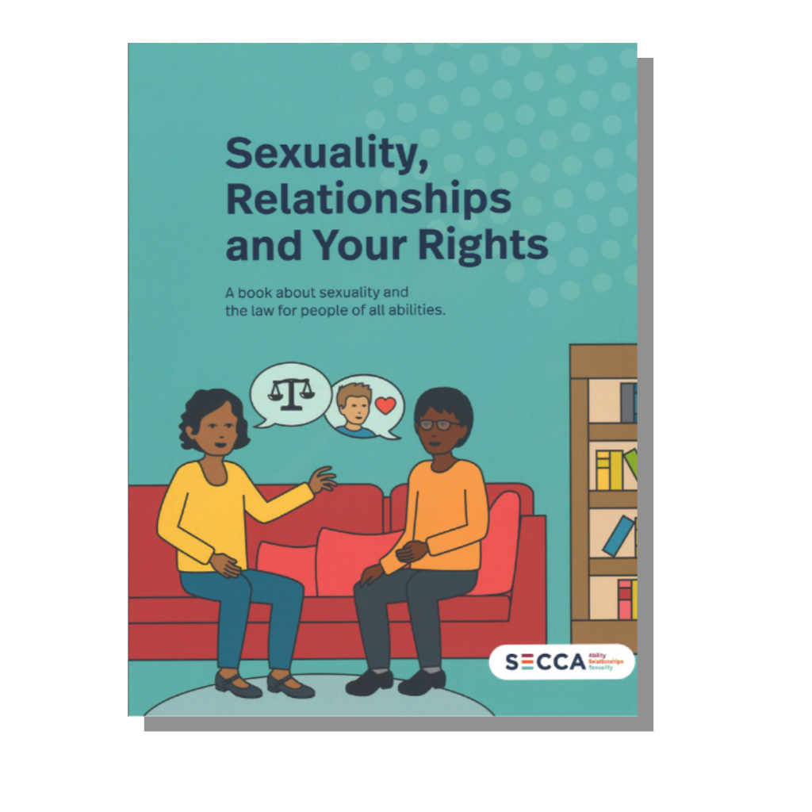
You can read the ‘Sexuality, Relationships and Your Rights’ book from SECCA for information on pornography and the law https://www.secca.org.au/resources/sexuality-relationships-and-your-rights-resource
What do I do if I find out my child has looked at porn online?
You might find out your child has been looking for porn online.
This is OK.
It is normal for children to be interested in looking up sex and naked people online.

Your child might also tell you if they have seen some porn on the internet that has made them feel sad or uncomfortable.
If you find out your child has looked at porn on the internet, it is a good idea to talk to them about it.
Here are some things you can do to talk to your child about porn:
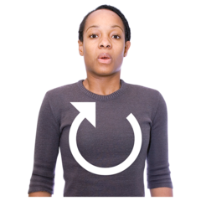
- Stay calm
You might feel upset or angry that your child has looked at porn online.
It is important to be calm so that your child can feel safe talking to you about what they saw.

- Learn about what happened
Ask your child how they found porn online and how they feel about what they saw. You can ask:
- how did they find the porn?
- did someone show it to them?
- how do they feel about what they saw?
- do they have any questions about what they saw?
Your child might be confused or sad about what they saw.
They might not know how to manage their feelings.
This is normal.

- Tell them that they are not in trouble
If your child is scared of getting into trouble, they might not talk to you about what they saw.
They might also try to hide what they saw or try to find more porn online.
Tell your child that they are not in trouble.
This will help them to feel more comfortable talking to you about what they saw.
- Talk to your child about the difference between porn and real life
There are lots of different types of porn. Some porn can be violent and scary.
Some children might think that what they see in porn is the same as what happens during sex in real life.

It is important to talk to your child about the differences between porn and real life.
This will help to protect their:
- self-esteem
- relationship development
- mental health
You can talk to your child about:
- consent
- healthy relationships
- what human bodies look like
- the difference between acting and real life

You can also go to the eSafety Commissioner to learn how to talk to children about porn: https://www.esafety.gov.au/parents/big-issues/online-pornography
What can I do if my child is obsessed?
If your child is obsessed with porn you should talk to a professional.
There are different support services and therapists who can help.
When children are obsessed with a topic, it can be very hard for families to help them without help.
It is important to remember that you are not alone.
You can find different support services in your area here.
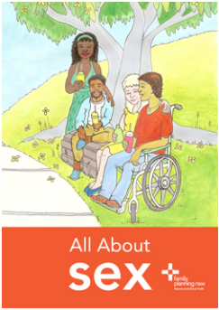
Resources for you to use:
All About Sex – Pornography fact sheet
Family Planning NSW

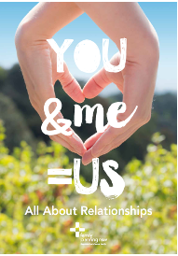
You & Me = Us
Family Planning NSW

https://www.esafety.gov.au/parents/big-issues/online-pornography
https://www.esafety.gov.au/parents/children-under-5/family-tech-agreement
https://www.esafety.gov.au/parents/skills-advice/taming-technology

https://secca.org.au/sites/default/files/SECCA%20Sexuality%20Your%20Rights%20Web.pdf
What to read next:
- Cybersafety
- Social Media and Relationships
- Healthy Relationships
For more information go to the Planet Puberty website
www.planetpuberty.org.au

